2.12: The cruising speed of the car is 60 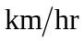 = 16.7 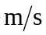. a) 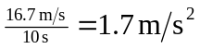 (to two significant figures). b) 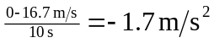c) No change in speed, so the acceleration is zero. d) The final speed is the same as the initial speed, so the average acceleration is zero.

